

Athena BBU User Guide

Software Version: 1.0
2017/10/16

Contents

Contents 2
Software Release History 4
1 General 5
1.1 purpose 5
1.2 intended audience 5
2 FHD kernel module usage 5
2.1 Memory verification mode 5
2.2 Memory dump mode 5
2.3 Specify the memory dump file path. 5
2.4 How to get memory dump information 6
3 BBU management tool usage 6
3.1 BBU Part Number command 6
3.2 BBU Assembly SN command 7
3.3 BBU Manufacture command 7
3.4 BBU FW Version command 7
3.5 BBU Battery Status command 7
3.6 BBU Temperature command 8
3.7 BBU Voltage command 8
3.8 BBU Current command 9
3.9 BBU Remain Capacity command 9
3.10 BBU Full Charge Capacity command 9
3.11 BBU Run Time To Empty command 10
3.12 BBU Required To Change command 10
4 GPIO read/write tool 11
4.1 build tool 11
4.2 Read GPIO 11
4.3 Write GPIO 11
4.4 Example 11

Software Release History

Revision | Date | Comments
1.0 | 2017-10-16 | Athena BBU User Guide
Table 1 - Software Release History

1 General

1.1 purpose
This document describes Athena BBU management tool and driver usage. The management tool is used to management the BBU status and information. The FHD driver is used to handle the fire hose dump for canister when NMI interruption triggered such as canister hot plug or BMC send NMI trigger command.

1.2 intended audience
The intended audience of this document is:
- System architects
- Hardware engineers

2 FHD kernel module usage
Customer can use the cls_fhd driver to copy the contents of the system memory to SSD when in FHD (Fire Hose Dump) mode. When customer pull out the canister or send BMC NMI command, cls_fhd driver will handler the NMI interrupt and do the memory dump from RAM to SSD.

Note1: Before installing the cls_fhd driver, you need to execute the following command by using the i2ctool: i2cset -y 1 0x67 0x05 0x44

Note2: For kernel version >= 4.7 and < 4.14, dpc driver must be removed, because when the CPLD go into dump mode it will power off all PCIe devices which will make the OS crash.

Note3: Has been tested on CentOS 7.3, CentOS 7.4, 4.9.74 (CentOS 7,4), 4.14.12 (CentOS 7.4), Ubuntu 16.04.

2.1 Memory verification mode
“insmod” cls_fhd.ko with option verify=1 will enter memory verification mode.
When customer pulls out canister and plull in canister in 5 seconds, driver will allocate memory from RAM and output to the “memory_dump.bin” file. We can verify whether the data is right later.
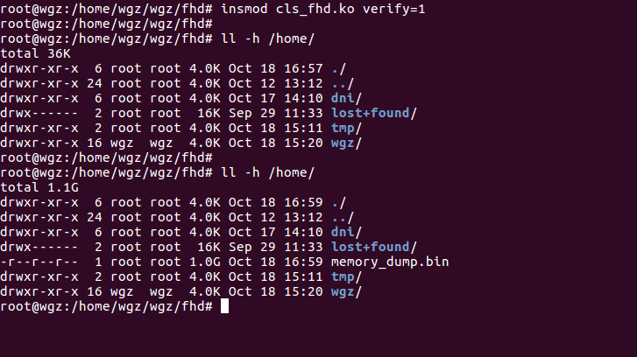

2.2 Memory dump mode
“insmod” cls_fhd.ko without verify options will enter the memory dump mode when NMI interrupt occur. There are 3 NMI trigger sources.
1 IPMI command for NMI through BMC management port.
2 power down
3 hot plug canister

When NMI interrupt occurred, the driver will copy the contents of the system memory to SSD. Memory data is in file “memory_dump.bin” in 3 minutes before the BBU charge to empty.
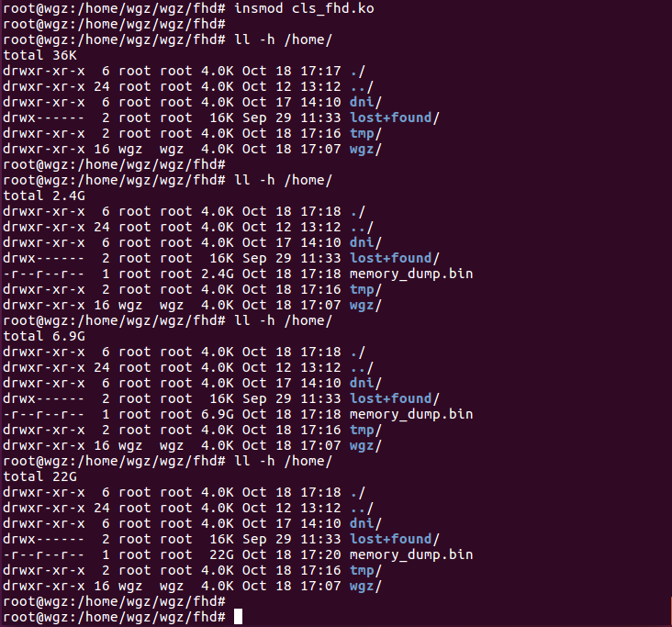

2.3 Specify the memory dump file path.

We can specify the location of memory dump file through option “path”
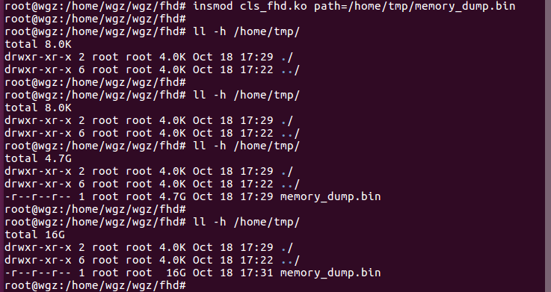

2.4 How to get memory dump information
Customer can use“dmesg”command to get detail memory dump information.

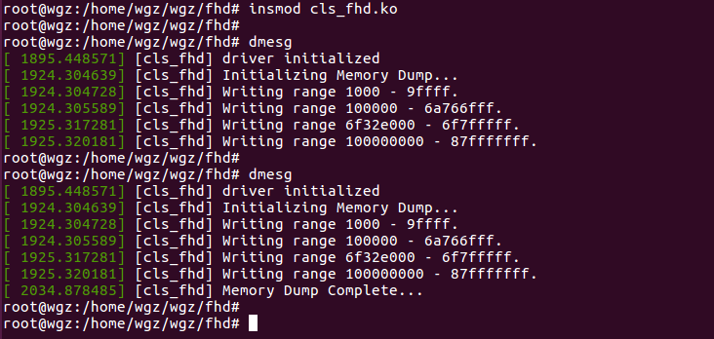

3 BBU management tool usage
Customer can use the “bbuapp” application to get the management information from BBU. BBU access is based on i2c regular driver i2c-i801 which has been supported by most of the Linux OS. Please make sure modprobe this driver and install i2c-tools before using “bbuapp”. Below is the commands list support now.
Do these commands before using the bbuapp.
modprobe i2c-dev
modprobe i2c_i801

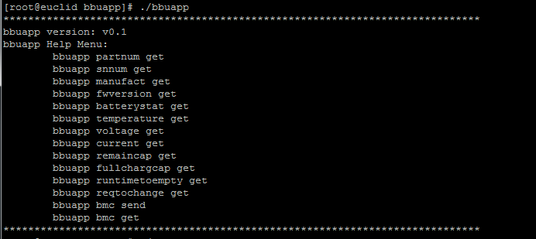

3.1 BBU Part Number command
Description:
This function returns a character array containing the battery's manufacturer's name. For example,
"MyBattCo" would identify the Smart Battery's manufacturer as MyBattCo.

Output:
Part Number string

Example:

3.2 BBU Assembly SN command
Description:
This function is used to return a serial number.

Output:
Serial Number

Example:

3.3 BBU Manufacture command
Description:
This function is optional and its meaning is implementation specific. It may be used by a battery
manufacturer or silicon supplier to return specific version information, internal calibration information, or
some other manufacturer specific function.

Output:
Manufacture string.

Example:

3.4 BBU FW Version command
Description:
Returns the version number of the Smart Battery specification the battery pack supports.

Output:
Version number

Example:

3.5 BBU Battery Status command
Description:
Returns the Smart Battery's status word which contains Alarm and Status bit flags.

Output: unsigned int - Status Register with alarm conditions bit mapped as follows:
* * * * * * Alarm Bits * * * * *
0x8000 OVER_CHARGED_ALARM
0x4000 TERMINATE_CHARGE_ALARM
0x2000 Reserved
0x1000 OVER_TEMP_ALARM
0x0800 TERMINATE_DISCHARGE_ALARM
0x0400 Reserved
0x0200 REMAINING_CAPACITY_ALARM
0x0100 REMAINING_TIME_ALARM
* * * * * * Status Bits * * * * *
0x0080 INITIALIZED
0x0040 DISCHARGING
0x0020 FULLY_CHARGED
0x0010 FULLY_DISCHARGED

Example:
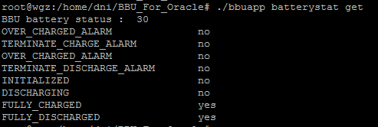

3.6 BBU Temperature command
Description:
Returns the cell-pack's internal temperature (°K). The actual operational temperature range will be defined
at a pack level by a particular manufacturer. Typically it will be in the range of -20°C to +75°C.

Output: unsigned int -- cell temperature in tenth degree Kelvin increments
Units: 0.1°K
Range: 0 to +6553.5°K
Granularity: 0.5°K or better
Accuracy: ±3°K

Example:

3.7 BBU Voltage command
Description:
Returns the cell-pack voltage (mV).

Output: unsigned int -- battery terminal voltage in milli-volts
Units: mV
Range: 0 to 65,535 mV
Granularity: 0.2% of DesignVoltage()
Accuracy: ±1.0% of DesignVoltage()

Example:

3.8 BBU Current command
Description:
Returns the current being supplied (or accepted) through the battery's terminals (mA).

Output: signed int -- charge/discharge rate in mA increments - positive for charge, negative for
discharge
Units: mA
Range: 0 to 32,767 mA for charge or
0 to -32,768 mA for discharge
Granularity: 0.2% of the DesignCapacity() or better
Accuracy: ±1.0% of the DesignCapacity()

Example:

3.9 BBU Remain Capacity command
Description:
Returns the predicted remaining battery capacity. The RemainingCapacity() capacity value is expressed in
either current (mAh at a C/5 discharge rate) or power (10mWh at a P/5 discharge rate) depending on the
setting of the BatteryMode()'s CAPACITY_MODE bit.

Output: unsigned int -- remaining charge in mAh or 10mWh

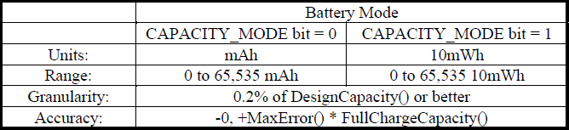

Example:

3.10 BBU Full Charge Capacity command
Description:
Returns the predicted pack capacity when it is fully charged. The FullChargeCapacity() value is expressed
in either current (mAh at a C/5 discharge rate) or power (10mWh at a P/5 discharge rate) depending on the
setting of the BatteryMode()'s CAPACITY_MODE bit.

Output: unsigned int -- estimated full charge capacity in mAh or 10mWh
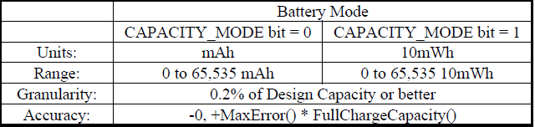

Example:

3.11 BBU Run Time To Empty command
Description:
Returns the predicted remaining battery life at the present rate of discharge (minutes).

Output: unsigned int -- minutes of operation left
Units: minutes
Range: 0 to 65,534 min
Granularity: 2 min or better
Accuracy: -0, +MaxError() * FullChargeCapacity() / Current()
Invalid Data Indication: 65,535 indicates battery is not being discharged

Example:

3.12 BBU Required To Change command
Description:
When BBU used for a long time, The Fall capacity will be smaller. We need to check the BBU Full capacity before we use BBU management tool. When the Full capacity can not support 2 power cycle. We suggest customer to change new BBU.

Output:
String to describe if we need to change the BBU.

Example:

3.13 BBU send status to BMC through IPMI tool.

BBU info get command. Get the data BMC received for check. BMC will format all the data every 1 minute.

BBU info send command. Send all the information of BBU to BMC through IPMI tool.

4 GPIO read/write tool
We have debug tool for GPIO read and write.

4.1 build tool
gcc pmrd.c -o read
gcc pmwr.c -o write

4.2 Read GPIO
Read GPP_D4
./read 0xfdae0000 0x4e0

4.3 Write GPIO
Write value 0x11 to GPP_D4
./write 0xfdae0000 0x4e0 0x11

4.4 Example
1. after removing AC power, the GPP_D0 vlaue will change from 0x00 to 0x10 indicating an NMI event occurs.
2. you need to write 0x10 to GPP_D0 to clear the NMI event caused AC power loss.
3. after removing AC power, the GPP_D4 value will change from 0x80820102 to 80820100. When AC power restored, its value restored to 0x80820102.
4. Our BBU driver useing GPP_D0 to indicate that AC power loss, using GPP_D4 to indicate AC power loss time duration.

5 know issues
#14165: SUT BBU: Continue to discharge even if power is restored more than 5 seconds. We design like that. It is normal action of BBU.
#14158: BBU APP: full charge capacity changed from 4524mA/mW to 4488mA/mW caused by power leak is normal action of BBU.

--- End of Document ---

